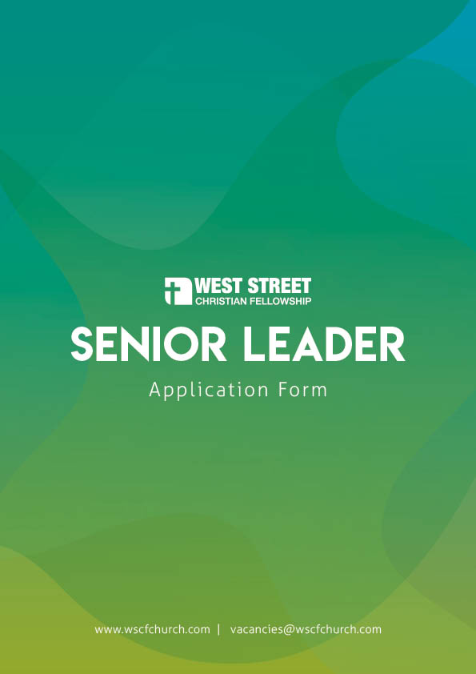
Please enclose your current CV with this application form, including your employment history, education and professional qualifications as a minimum.
As you complete this form, please feel free to enlarge any boxes if your answer requires more space.
Section 1: Personal Details
Surname: |  |  | Title:
First Name(s): | Please indicate the name you are generally called by:
Address:
Postcode:
Contact no: | Daytime: | Evening:
Email:
Employment  Status: | Do you have the right to live and work in the UK without a visa?  (WSCF does not have the ability to offer work visas) |  | YES / NO

Section 2: Current Situation
Please provide the following information about your current or most recent employment.
Job/Role Title:
Date you started:
Name of Employer:
Employer Address:
Please describe your role and areas of responsibility:
Please describe some of the changes during your time in post – areas of growth, developments, challenges and opportunities:
Reason for seeking to leave your current employment:
If you have already left, please provide the date.

Section 3: Your faith journey and ministry development
Please provide a description of your faith journey and development as a person and in ministry. This should include:
- When and how you became a Christian
- A description of your current spiritual life
- Your major spiritual influences
- What you consider to be your spiritual gifts and how you use them
We suggest approx. 1000 words:

Section 4: Your personal statement
Having looked at the job description and person specification, please explain why you consider yourself equipped and suitable for this role. Please provide a personal statement including:
- How you meet the criteria as described
- How your previous experience has prepared you for this role.
- Why you are making this application at this time
We suggest approx. 1000 words:

Section 5: Your leadership skills
Using examples, how would you describe your leadership style and how you work in a team?

Section 6: Your passions
What are your main passions and how do you see them fitting at West Street Christian Fellowship?
Please send us a film clip of yourself talking about this and send it with your application using https://wetransfer.com and sending it to vacancies@wscfchurch.com. It doesn’t need to be long – 1-2 minutes is fine. Nor does it need to be high quality – just a video from a mobile ‘phone will do. Please contact us if you require further guidance.

Section 7: Preaching
Please make a sample of your preaching available to us (via email, post, “wetransfer” or a link to a podcast or online recording).
Link or method of transfer:

Section 8: References
Please give details of 3 referees who know you well, including your current Church leader, an employer and excluding close relatives.
Please indicate if you would prefer a referee NOT to be contacted prior to interview.
Referee 1 – Current Church Leader
Title/Name |  | Role/Relationship:
Address
Contact no |  | Email:
Referee 2– Current or Previous Employer
Title/Name |  | Role/Relationship:
Address
Contact no |  | Email:
Referee 3 – Someone else who knows you well
Title/Name |  | Role/Relationship:
Address
Contact no |  | Email:

Section 9: Declaration
Are you in whole-hearted agreement with the West Street Christian Fellowship Statement of Faith provided in the information pack? |  |  | YES / NO
I declare that all the information given in this application is accurate and complete to the best of my knowledge. I understand that if any information I have provided is found to be untrue any offer may be withdrawn or any contract of employment may be terminated.
I consent to West Street Christian Fellowship processing the information detailed in this application form for the purposes of this appointment procedure, conditional upon West Street Christian Fellowship complying with the Data Protection Act 1998 and General Data Protection Regulations 2018.
As this position involves substantial contact with children, young people and vulnerable adults, I understand that any job offer will be subject to an enhanced DBS (Disclosure and Barring Service) check and the completion of a Self-Declaration Form before the post can be confirmed.
I understand that because of the nature of the work involved in this post, it is exempt from the provisions of Section 4(2) of the Rehabilitation of Offenders Act 1974 by virtue of the Rehabilitation of Offenders Act 1974 (Exceptions) Order 1975. This means that I am not entitled to withhold information about convictions which for other purposes are 'spent' under provisions of the Act. In the event of employment, failure to disclose such convictions could lead to disciplinary action being taken. I understand that West Street Christian Fellowship will treat any information I provide with the strictest confidence and it will be used solely in relation to this application.
Signature: |  | Date:

Thank you for taking the time to complete this application form.

Please send your completed application form, along with an up-to-date CV and any accompanying files to Andy Page at vacancies@wscfchurch.com.

Alternatively they can be posted to the address below marked “STRICTLY PRIVATE AND CONFIDENTIAL”:
Mr Andrew Page
West Street Christian Fellowship
Maybury Centre
96 West Street
Crewe
CW1 3HE

If you have any queries about the application process please speak to our administrator Ruth Grimshaw on 01270-255337, who will either help you directly or put you in touch with someone who can.

All applications must be received by the deadline: 12th October 2018

